Academic Sessions University of Ruhuna 2024
ASUOR2024 - CMT Guidelines
- Use the following link to access to the Microsoft Conference Management System (CMT)
https://cmt3.research.microsoft.com
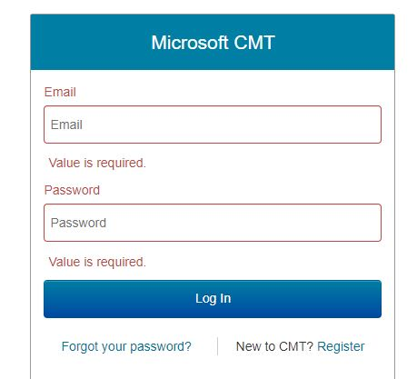
- Registered users: enter your CMT login credentials [1] and click “Log In” button (if you’re new to CMT, click “Register” link [2] to create a new account)
1
2

- Under “All Conferences” [3], search for; “Academic Sessions University of Ruhuna 2024” [4] and click on it.
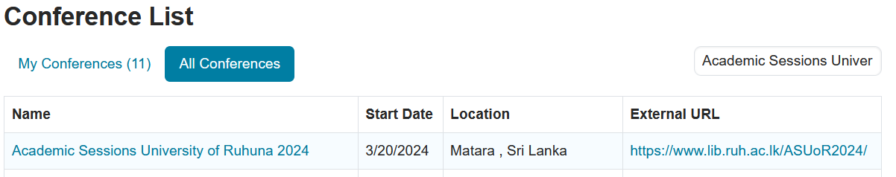
4
3

- To login into the Author Console, click on “+Create new submission” [5].
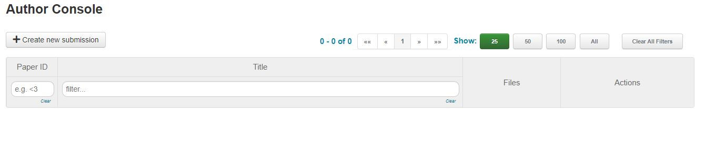
5

- Under “Create New Submission”, type your “Title” and “Abstract”. Author instructions can be found at https://www.lib.ruh.ac.lk/ASUoR2024/

- In the “Authors” section, add the details of the authors.
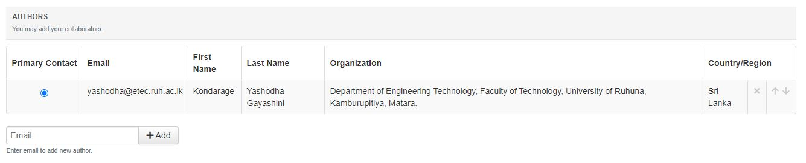

- In the “Subject Areas” section, Select your “Primary” subject area and further you can select up to one secondary subject area.
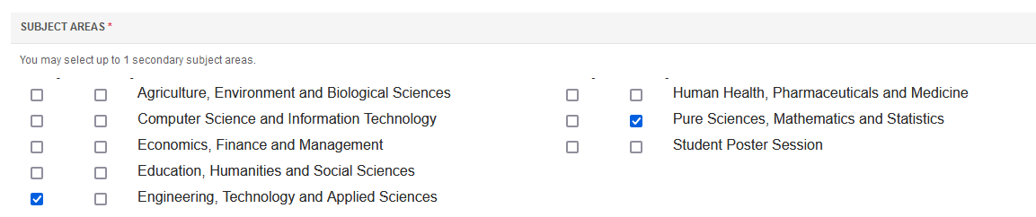
- If you submit for the poster session for students, select “Student Poster Session” as the secondary subject area.
- Under the “Files” section, you can upload your Abstract and the Extended Abstract as requested.
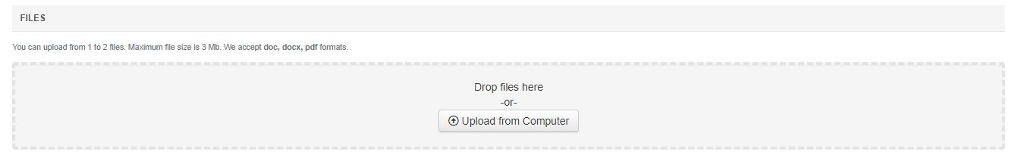

- In the “Additional Questions” select your author category. Click on the “Submit” button for submission [6].
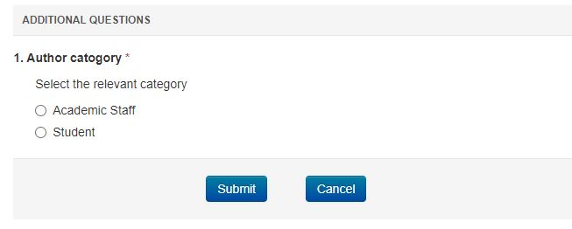
6

- You can go back to your “Author Console” and check your submission status. You can upload supplementary materials (Author declaration and etc.) by clicking on “Upload Supplementary Materials” [7].
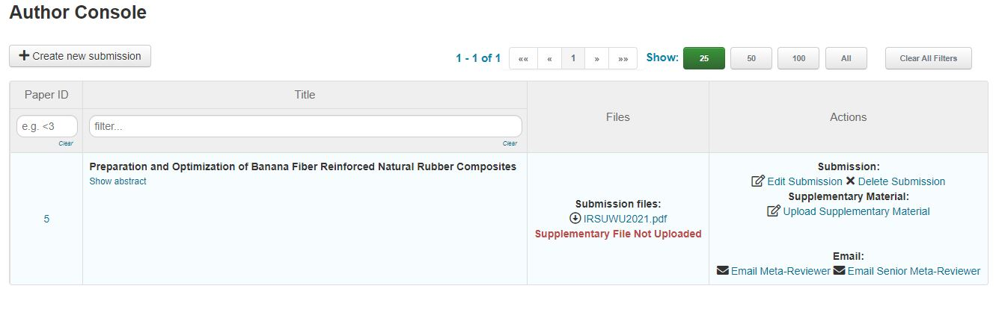
7

- You will receive the notification through the system and via emails.
    - Status of the abstract (Acceptance/revision etc.)
    - Reviewers’ feedbacks
    - Revision submission
    - Camara ready copy submission
    - Other decisions (oral/poster)

- Please check your accounts after different deadlines:

